The Leek Area Team Benefice

and the Hermione Warren Trust

are looking to appoint a

Warden for

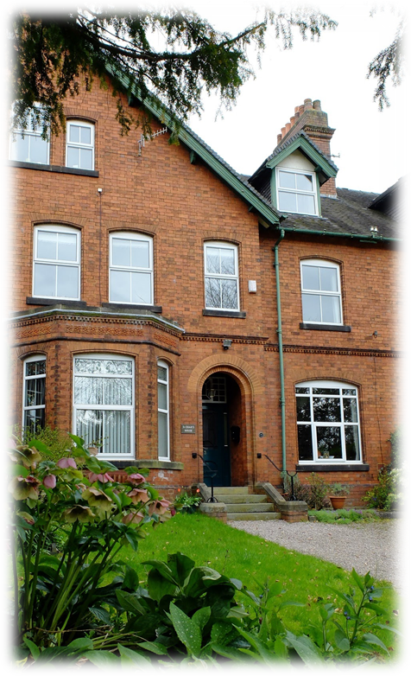St Chad’s Retreat House

**St Chad's House,**

**3 Southfields, Leek, Staffordshire, ST13 5LR**

# About St Chad House

St Chad’s is a retreat house left to the church and town by a local Christian lady, Hermione Warren, whose wish was that the house be used as a place of healing and retreat. It is run in a style that draws from the traditions of Celtic spirituality.



A body of trustees oversees the legacy and the maintenance of the house but the day to day running depends on voluntary donations.

The house has a chapel and a well-stocked library with books on the healing ministry and Celtic spirituality. There is a sitting room with lovely views of the Ladydale valley.

St Chad’s resident warden is supported by the Anglican Staff Team of the Leek Area Team Beneifice.

*View from the sitting room at St Chad’s*

**What does St Chad’s offer?**

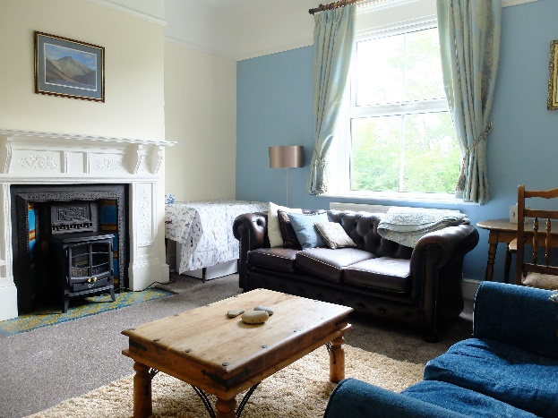A spacious house in a quiet location (not off the beaten track) Open views and nearby walks

Quiet Days

Drop in afternoons

Facilities for small groups to meet (usually a maximum of around 12 people)

Parish groups, individuals or friends are all welcome.

Short stay accommodation in a self-contained flat on the first floor of the house for a person or couple in need of rest and refreshment.

Food and drink available on request.

*Lounge in guest accommodation*

# The Vision for St Chad’s House

To be a place of prayer for healing of individuals,

communities and nations.

To be a place where people can come for

quiet and spiritual refreshment.

To be a place where soul friends meet

and share their journeys

To be a place that provides facilities

for studies in Celtic Spirituality

*St Chad’s Library*

# Warden of St Chad’s House, Leek

**Job Description**

## 1. Appointment

This is a House-for-Duty post for which the expected working hours equate to a half time role. No financial remuneration will be paid to the honorary Warden for the exercise of his or her duties. The honorary Warden is the tenant of the Trustees (The Hermione Warren Trust). The Warden is appointed by the Team Benefice and their ministry is supervised by the PCC of St Edward the Confessor, Leek on behalf of the Trsutees.

## 2. Aim

To manage St. Chad’s House as a centre for the ministry of prayer, healing, hospitality and spiritual formation.

## 3. Duties

1. Maintain a rhythm of prayer drawing on resources from the Anglican and Celtic traditions.

2. Host the weekly Team Staff Meeting and occasionally other Team initiatives such as for

example Lent Courses or Confirmation Preparation Courses as agreed.

3. Plan and lead a monthly quiet day (which outside speakers can be invited to) and another more informal monthly fellowship event.

4. Offer the ministry of listening and prayer for healing.

5. Host day meetings of groups from local churches or Christian organisations.

6. Offer hospitality to individuals and groups using the House as day visitors or for occasional

overnight stays through the provision of simple meals and ensure the house is kept clean and welcoming.

7. Develop awareness of and promote the ministry of St. Chad’s through the Team Benefice, the Diocese and other networks and them informed of news and events through posters and leaflets and other information by email and on the internet.

8. Develop and maintain a suitable support group who will give practical, prayer or

financial support through personal and local church contacts.

9. Plan awareness and fundraising events such as coffee mornings, garden parties etc.

10. Keep accounts for the House and submit these to the Chair of the Hermione Warren Trust.

11. Work with the Vicar of All Saints (when in post) who has a chaplaincy role to the House.

12. Explore other activities and initiatives appropriate to the purpose of the house with the

parish clergy and the trustees.

## 4. The Person

*The Warden will:*

* commit themselves to growing and deepening their own life of prayer and that of others
* offer hospitality and welcome to those who visit the house whatever their background
* be ready to listen to others and demonstrate confidence in his or her own Christian faith
* embrace both the Anglican and Celtic traditions of spirituality
* create a space in which people can experience the healing power of God for themselves
* plan, facilitate and deliver monthly quiet days incorporating simple acts of worship
* maintain good relationships with other members of the Staff Team (comprising the Team Rector and other stipendiary clergy) and communicate effectively with them

## 5. Management and Support

1. The Warden will be a member of the Leek Area Team Benefice Staff and will be invited to attend the weekly staff meetings (which are currently held on Mondays at 9.30am).
2. The Warden will be immediately responsible to the Team Rector with whom they will meet regularly (usually once a month) to review the work of the house.
3. The Warden will be offered help in setting up an informal support group if that is something they would value.
4. The Warden will establish a pattern of working and rest days in consultation with the Team Rector.
5. Holiday entitlement will be six weeks per annum.
6. The Warden will meet periodically with the PCC of St Edward’s Church and with the Trustees of the Hermione Warren Trust to talk about the work of the house.
7. The Warden will be provided with free accommodation with costs of water rates, council tax and repair of house equipment and utilities being met by the owners. The Warden will contribute an agreed sum towards the costs of gas, electricity and telephone charges and the remainder will be covered by the owners.
8. The Trustees will ensure that proper and adequate insurance is in place for the fabric and contents of the property and third-party public liability for events held there will be provided by the PCC of St Edward’s Church under whose supervision the ministry of the House operates. The Warden will be responsible for taking out insurance cover for their personal belongings.
9. There is no salary with this post but money paid into the St. Chad’s House Account is available to cover running costs, this account includes donations from guests and the local churches in the Team Benefice.

**6. Finance, Fabric and Tenancy**

1. The Warden will occupy St Chad’s House rent free.

2. The Trustees will provide furnished accommodation.

3. The Trustees will be responsible for the upkeep of the fabric of the property and for regular maintenance and repairs including an annual service of the gas installation and appliances.

4. The Trustees will pay for the full cost of Water Rates and Council Tax.

5. The Warden will be responsible for keeping the interior of the house in a neat, clean and tidy condition at all times, and for the purchase of domestic consumable items from the House Fund.

6. The PCC of St Edward the Confessor (with the agreement of the Trustees) or the Warden may end the tenancy by giving 3 months notice thereof.

# The History of the Leek Area Team Benefice

The Leek Team Ministry in the Church of England Diocese of Lichfield was established in 1979 with the Parishes and Benefices of St Edward’s with St John’s, All Saints and St Luke’s with St Paul’s uniting together at that time. The Parish of St Matthew’s united with the new Parish of Leek in 1983 to create the Leek & Meerbrook Team Parish. This then became the Leek and Meerbrrok Team Benefice in November 2020 and was subsequently expanded to become the Leek Area Team Benefice in February 2025. This include the six parishes of St Edward the Confessor, Leek; St Luke’s & St Paul’s, Leek; All Saints, Leek; St Matthew’s, Meerbrook; St Edward the Confessor, Cheddleton and St Chad’s, Longsdon.

There is great diversity within the Team with space for a wide variety of Christian spirituality. We value the distinctive contribution made by each congregation. Each parish is responsible for its own mission and ministry but, where appropriate, we pool resources and work together. The team of ministers consists of the Team Rector and the two Team Vicars. You can find out more about the life of the Team by going to **www.leekparish.org.uk**

# The Town of Leek

The North Staffordshire market town of Leek is located some 12 miles north-east of the city of Stoke-on-Trent in the Staffordshire Moorlands, bordering on Derbyshire, Cheshire and the Peak National Park. Leek lies within the parliamentary constituency of Staffordshire Moorlands and the area is administered by the Staffordshire Moorlands District Council and Leek Town Council.

It is an area of outstanding beauty with a mixture of rugged crags, meandering river valleys, lakes, woodlands and rolling pastureland. Farming is prevalent within the area, particularly with livestock. The town's charm and the area's beauty are the cause of an expanding tourist industry discovering this part of England.

Historically a mill town, in recent years the dyeing and manufacturing mills have reduced to be replaced by commerce and other light industry providing employment for the 20,000 inhabitants.

Each Wednesday, and Saturday and once a month on Sunday a market that dates back to King John is held in the town square and other places in the town centre. A livestock market is held on Tuesday and this is now on the outskirts of the town. The shopping areas have a variety of shops catering for every requirement with a healthy balance of independent and nationally known retailers.

The education system includes 4 church schools linked to parishes in the Benefice which has a three tier First, Middle and High School system (ages of transfer being 9 and 13 years). Both of the two high schools, Westwood and Leek High, run 6th Forms and Leek & Buxton College also has a campus in the town offering a range of courses both full time and vocational.

**Applications for this post should be made on the form provided below and sent either by post to the Team Rector Revd Nigel Irons, 24 Ashenhurst Way, Leek, ST13 5SB or by email to** [***stedwardsleek@hotmail.com***](mailto:stedwardsleek@hotmail.com)**and should be submitted by Monday 8th September 2025.**

**If you would like further information about the House please feel free to contact the Team Rector on 01538 386114.**

**Application for the post of Warden of St Chad’s House, Leek**

Please return this application by email to[*stedwardsleek@hotmail.com*](mailto:stedwardsleek@hotmail.com)

or by post to Revd Nigel Irons, 24 Ashenhurst Way, Leek, ST13 5SB

to reach us by 8th September 2025.

Name:

Address:

Telephone number:

Email:

Date:

Qualifications:

Curriculum Vitae:

Why are you applying for this post and what do you feel you have to offer which equips you well for it?

Names and addresses of three referees who can testify to your suitability for this role:

*The appointment will be subject to the procurement of a satisfactory DBS check by the successful applicant(s) which will be arranged through the Diocese of Lichfield.*